**St. Brigid’s Primary / Nursery School**

**PDMU Policy**

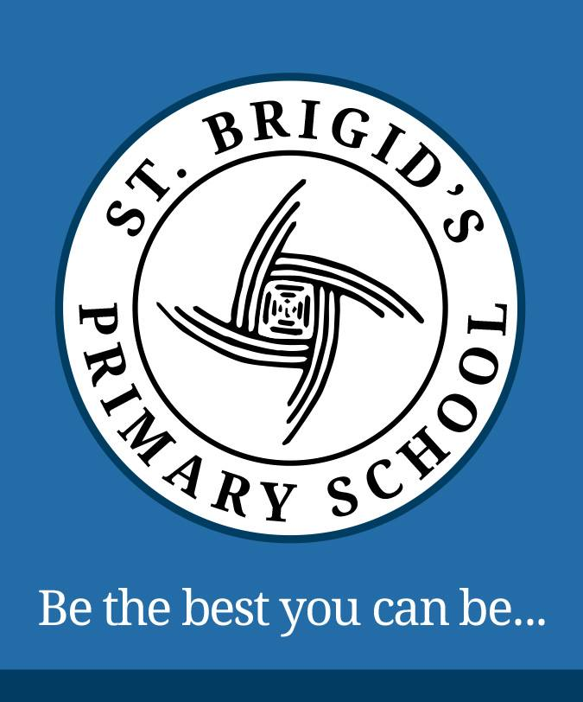

Policy Reviewed Spring 2023

Next Review Date: Spring 2026

Signed: __________________ (Chair of Governors)

Signed: __________________ (Principal)

**ST. BRIGID’S PRIMARY / NURSERY SCHOOL**

**Personal Development and Mutual Understanding**

**Principles**

Personal Development and Mutual Understanding focuses on encouraging each child to become personally, emotionally, socially effective, to lead healthy, safe and fulfilled lives and to become confident, independent, resilient and responsible citizens, making informed and responsible choices and decisions throughout their lives.

PDMU is fundamental to the development of the child.

**Mission Statement**

**“Be the best you can be”**

St. Brigid’s Primary School strives to promote primary education of the highest quality for all pupils, in a nurturing, secure and stimulating environment where every pupil is valued and supported to become confident, challenged and successful learners.

**Rationale**

In today’s increasingly challenging and changing society PDMU focuses attention on pupil’s emotional development, health and safety, relationships with others and development of moral thinking, values and actions. The Northern Ireland Curriculum seeks to give greater emphasis to Personal Development and Mutual Understanding (PDMU) which it considers to be an important element within the curriculum.

PDMU supports the Northern Ireland’s Curriculum’s Aim:

**‘*To empower young people to achieve their potential and to make informed and responsible choices and decisions throughout their lives.’***

**Through PDMU we will develop pupils’:**

* Ability to show resilience at challenging times of their lives
* Self-confidence and self-esteem as individuals and a spiritual appreciation of their uniqueness
* Insights into their own emotions, attitudes and moral values and how they are formed;
* Understanding of the benefits and importance of a healthy lifestyle
* Insights into society, other cultures and the environment, our interdependence and the need for mutual
* Understanding and respect
* Ability to use these insights to contribute to relationship’s family life, the local and global community and the environment
* Awareness of the immense value of personal and interpersonal skills in future life and employment
* Contexts, through our class/school council work.

**Practices**

**Approaches**

PDMU is therefore one of 6 Areas of learning within the Northern Ireland Curriculum focusing on emotional development, social skills, learning to learn, health, relationships and sexuality education and mutual understanding in the local and global community.

**Personal Development has two Strands:**

* **Personal Understanding and Health;**
* **Mutual Understanding in the Local and Global Community;**

Personal Development has, at its core, the development of values and attitudes. It is extremely important that the children have the opportunity to develop these naturally as a consequence of their investigations and guided critical reflection on issues. Learning should therefore be active, with children being encouraged to investigate issue for themselves, to suggest solutions and to make decisions based on what they have learned.

As Strand two of Personal Development focuses on aspects of the local community, children should have experience of activities involving the investigation and exchange of ideas about the local community issue especially those reflecting cultural difference, in at least one of the following ways:

* Within the school complemented by relevant visitors or visits; and/or
* Within the school, enhanced by communication between schools, with the possibility of joint visits to a common venue or to each other’s school;
* Joint work between schools, involving, for example, shard educational visits, residential, fieldwork or international contact.

There are several useful strategies for creating a safe, secure environment that encourages participation and model democratic values.

These include:

* Mind up programme
* Mindfulness lessons
* Build resilience skills
* Bounce back programme
* Circle time lessons
* Active listening skills
* Cooperation games
* Use active and participatory learning methods
* Agreed rules/contracts/classroom charter /code of conduct
* Follow an issues-based approach

**Classroom Management of Resources**

* Northern Ireland curriculum document sets out the minimum content for each Key stage The PDMU Guidance booklet give further detail on strategies, planning and assessment. Every teacher has a copy.
* More information on assessment methods and self -assessment is available in the \assessment for learning guidance booklet located in the Revised Curriculum support and Implementation Box.
* The Mind Up Programme - Based firmly in neuroscience, Mind Up Programme teaches the skills and knowledge children need to regulate their stress and emotion, form positive relationships, and act with kindness and compassion.

**Planning, Monitoring and Evaluation**

* PDMU continues to be priority in our School Development Plan
* PDMU is embedded into the schemes of work
* PDMU is integrated into the half term planners taking account of progression
* An overview scheme based on lines of development from y\ear 1 to Year 7 has been drawn up and is used by staff. \this focuses on key skills and knowledge

**Assessment / Recording**

Assessment is an integral part of the teaching process

When assessing children’s PDMU, the following will be considered

* Review progress
* Setting targets
* Negotiating their own pathways
* Recording their achievement
* Ongoing self-assessment through school council meetings/tasks

**The Role of the Principal:**

· The principal and SLT will set priorities and targets and ensure their implementation promote the development of PDMU in a variety of ways.

· In consultation with the coordinator and staff he will decide on how the subject is to be implemented into the daily life of the school

· The principal will encourage the continued training of all staff and

· Support and consult with the coordinator, acting as a channel between the staff and the Board of Governors.

· Monitor and review the subject’s progression with the support of his Strategic Leadership Team.

**The Role of the PDMU Coordinator:**

The PDMU coordinator will:

* Liaise with the principal and all staff in the drawing up and reviewing of the PDMU policy.
* Oversee the drawing up of plans across the curriculum to incorporate the nine themes of PDMU.
* Compile a bank of usable and recommended resources for teachers to use in class to support teaching.
* To insure RSE is incorporated into the PDMU scheme.
* To monitor the year group planning for PDMU.
* To support staff to use PDMU effectively in their classrooms.
* Ensure Circle Time/Mind Up lessons are used effectively to promote PDMU principles.

**The Role of the Classroom Teacher**

In recognition of the fact that we all learn in different ways, a range of learning styles and teaching strategies is employed. These approaches emphasise group and collaborative ways of working that maximise opportunities for pupil input, decision making and problem-solving.

Lessons are conducted in a non-judgemental atmosphere with the teacher in the role of facilitator, where a safe and supportive environment is maintained. Empathetic relationships based on mutual respect are developed to create a place where fears and concerns can be expressed openly; where children can “have a go” without risk of ridicule or reproach.

**How will it be delivered?**

For PDMU to be effective, the teachers will develop and explore a number of strategies

Delivered as an individual subject area with time set aside on each class’ weekly timetable. – The Mind Up Programme.

Developed through all other areas of the Curriculum and will help support all aspects of teaching and learning.

Use the **Nine Strands** throughout the school year to develop all areas within the Living. Learning. Together Programme.

1. Self-awareness

2. Feelings and Emotions

3. Learning to Learn

4. Health, Growth and Change.

4a. Safety

5. Relationships

6. Rules, Rights and Responsibilities

7. Managing Conflict 8. Similarities and Differences

9. Learning to live as members of the community

## HEALTH AND SAFETY

* Teachers will ensure that trust is developed, and a safe environment is provided for all pupils.
* Educating children about risks and how to protect themselves from danger has a significant impact

on their health and well-being.

* Teaching emotional and social health in the classroom leads to increased attachment to school and

improved educational outcomes.

**Links across the Curriculum**

PDMU has strong links with the other five areas of learning and can be explored through a range of topics and learning methods:

**The Arts:**

· Help children to explore ways of expressing themselves through drama, music, art and design. Language and Literacy:

· Help children to develop vocabulary to discuss emotions and feelings through talking and listening, reading, independent writing, drama and role play situations.

**Mathematics and Numeracy:**

· Use statistics to inform children and for gathering of information they have gathered in surveys and questionnaires.

**Physical Education:**

· Help children to develop self-esteem, confidence, be aware of health and exercise.

· Develop working as a group or team, to develop their awareness of fairness and treating others with respect.

**The World Around Us:**

· Help children to understand other cultures and other places and times. Develop their awareness of their own talents, thoughts and feelings.

**Related School Policies**

In addition to curricular links this policy is set against the broader context of pastoral care and should be read in conjunction with the following school policies:

· Pastoral Care Policy

· Teaching and Learning Policy

· Child Protection/ Safeguarding Policy

· Anti-Bullying Policy

· Drugs Policy

· Relationships and Sexuality Education

• Positive Behaviour Policy

## POLICY REVIEW

* The PDMU policy will be reviewed tri annually by Principal and PDMU coordinator in collaboration with the whole staff.