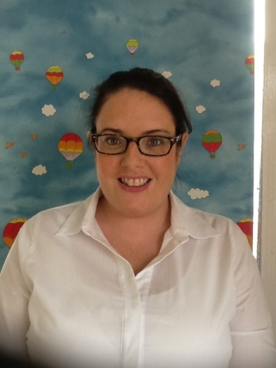

**Designated CP Governor**

**Mr T Doherty**

**Chairperson**

**Board of Governors**

**Mrs M Morrison**

Designated

Teacher

Mr O’ Doherty

Chair of

SGCP team

Ms Mc Callion

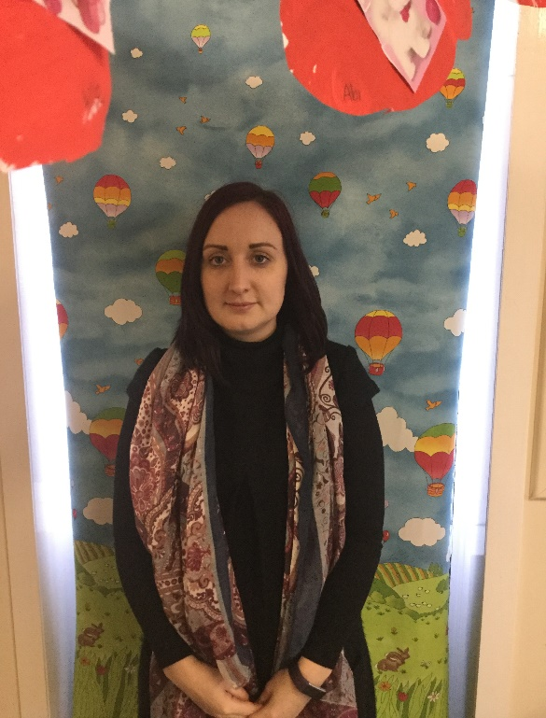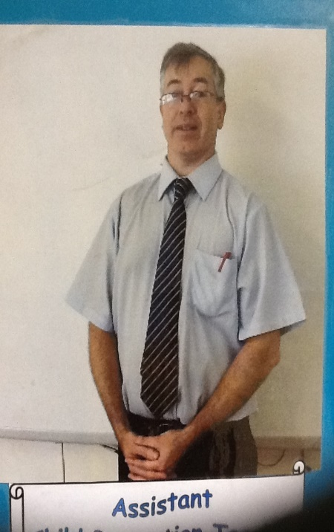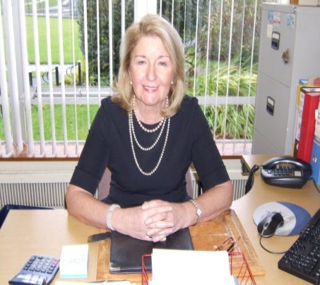

Designated Teacher

ASD/LSC

Mr Doherty

Designated Teacher

Nursery

Mrs Quigley

Deputy Designated Teacher

Miss Mc Namara