St Brigid’s Primary School/Nursery Unit
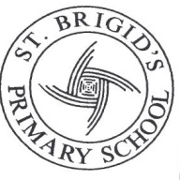
& Autistic and Learning Support Classes.
Carnhill Estate
Derry City
Northern Ireland

BT48 8BZ
Derry City
N. Ireland
BT48 8BZ

Tel : 028 71351929

Fax: 028 71351767
E-Mail: info@stbrigidsps.derry.ni.sch.uk

Website: www.stbrigidspsderry.com

19 November 2018

Milk for the Month of December 2018 is £3.00

Milk money must be paid no later than Tuesday 27 November to receive milk on
Monday 3 December.

We must give the milk order to Dale Farm on this date to ensure we have the milk for the following week.
Once they receive the order they do not allow any changes to be made.
Please make sure you have paid by this date to ensure your child gets their milk for the month.

In order to ensure that the correct amount of milk is ordered for each class all milk money must be paid directly to your child’s class teacher.

Yours sincerely

_________________
Mary McCallion
Principal

